***Cascading Style Sheets***

1. **Ways to link CSS**

<!DOCTYPE html>

<html>

<head>

<title>Ways to link CSS | Shubham Dahiya</title>

<!-- linking external css -->

<link rel="stylesheet" href="mystyle.css">

<!-- Internal CSS -->

<style>

body {

background-color: lightblue;

}

</style>

</head>

<body>

<h1>Ways to link CSS</h1>

<!-- Inline CSS -->

<h1 style="color:orangered; text-align:center">This is a heading</h1>

<p style="color: pink">This is a paragraph.</p>

</body>

</html>

**OUTPUT:**

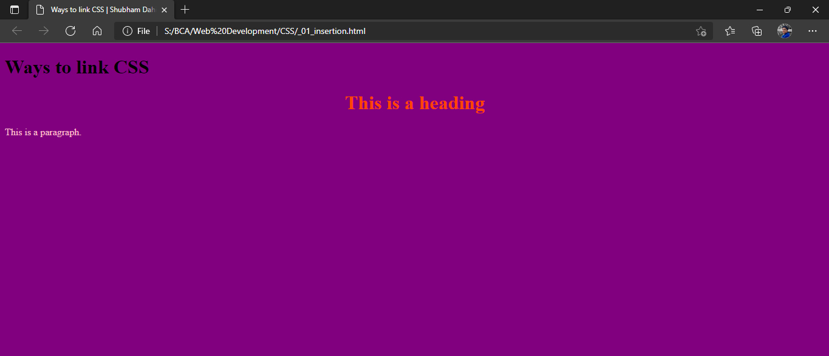

1. **Border types**

<!DOCTYPE html>

<html>

<head>

<title>Border types | Shubham Dahiya</title>

<style>

p.dotted {border-style: dotted;}

p.dashed {border-style: dashed;}

p.solid {border-style: solid;}

p.double {border-style: double;}

p.groove {border-style: groove;}

p.ridge {border-style: ridge;}

p.inset {border-style: inset;}

p.outset {border-style: outset;}

p.none {border-style: none;}

p.hidden {border-style: hidden;}

p.mix {border-style: dotted dashed solid double;}

</style>

</head>

<body>

<h2>The border-style Property</h2>

<p>This property specifies what kind of border to display:</p>

<p class="dotted"> dotted border.</p>

<p class="dashed"> dashed border.</p>

<p class="solid"> solid border.</p>

<p class="double"> double border.</p>

<p class="groove"> groove border.</p>

<p class="ridge"> ridge border.</p>

<p class="inset"> inset border.</p>

<p class="outset"> outset border.</p>

<p class="none">No border.</p>

<p class="hidden"> hidden border.</p>

<p class="mix"> mixed border.</p>

</body>

</html>

**OUPTUT:**

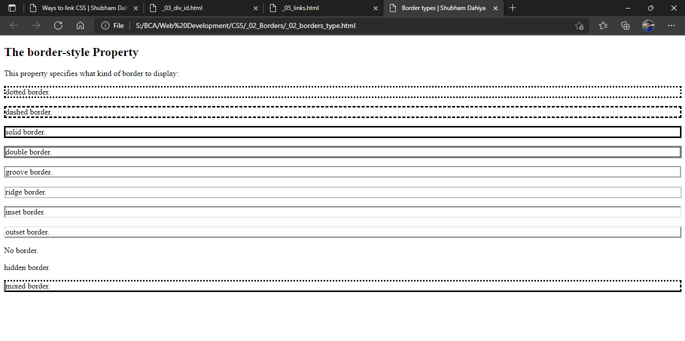

1. **Border width**

<!DOCTYPE html>

<html>

<head>

<title>Border width | Shubham</title>

<style>

p.one {

  border-style: solid;

  border-width: 5px;

}

p.two {

  border-style: solid;

  border-width: medium;

}

p.three {

  border-style: dotted;

  border-width: 2px;

}

p.four {

  border-style: dotted;

  border-width: thick;

}

p.five {

  border-style: double;

  border-width: 15px;

}

p.six {

  border-style: double;

  border-width: thick;

}

/*Specic side widths*/

p.seven {

  border-style: solid;

  border-width: 25px 10px 4px 35px; /* 25px top, 10px right, 4px bottom and 35px left */

}

</style>

</head>

<body>

<h2>The border-width Property</h2>

<p>This property specifies the width of the four borders:</p>

<p class="one">Shubham Dahiya</p>

<p class="two">Shubham Dahiya</p>

<p class="three">Shubham Dahiya</p>

<p class="four">Shubham Dahiya</p>

<p class="five">Shubham Dahiya</p>

<p class="six">Shubham Dahiya</p>

<p class="seven">Shubham Dahiya</p>

<p><b>Note:</b> The "border-width" property does not work if it is used alone.

Always specify the "border-style" property to set the borders first.</p>

</body>

</html>

**OUTPUT:**

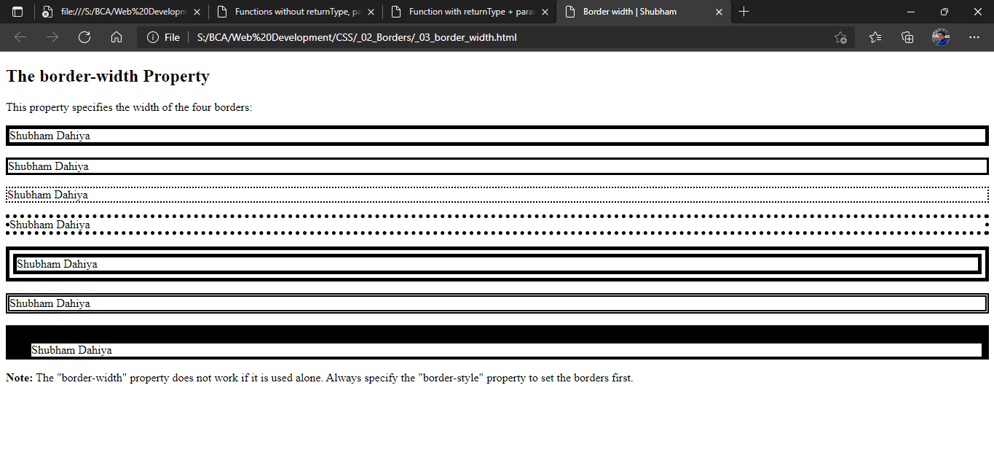

1. **Border color**

<!DOCTYPE html>

<html>

<head>

<title>Border color | Shubham Dahiya</title>

<style>

p.one {

  border-style: solid;

  border-color: red;

}

p.two {

  border-style: solid;

  border-color: red green blue yellow;

}

</style>

</head>

<body>

<h2>The border-color Property</h2>

<p>This property specifies the color of the four borders:</p>

<p class="one">A solid red border</p>

<p class="two">A specific border color</p>

<p><b>Note:</b> The "border-color" property does not work if it is used alone. Use the "border-style" property to set the borders first.</p>

</body>

</html>

**OUTPUT**:

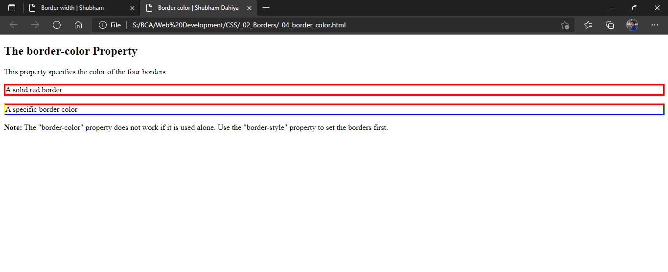

1. **Border sides**

<!DOCTYPE html>

<html>

<head>

<title>Border Sides | Shubham Dahiya</title>

<style>

p {

  border-top-style: dotted;

  border-right-style: solid;

  border-bottom-style: dotted;

  border-left-style: solid;

}

</style>

</head>

<body>

<h2>Individual-Side Border Sides</h2>

<p>2 different border styles.</p>

</body>

</html>

**OUTPUT:**

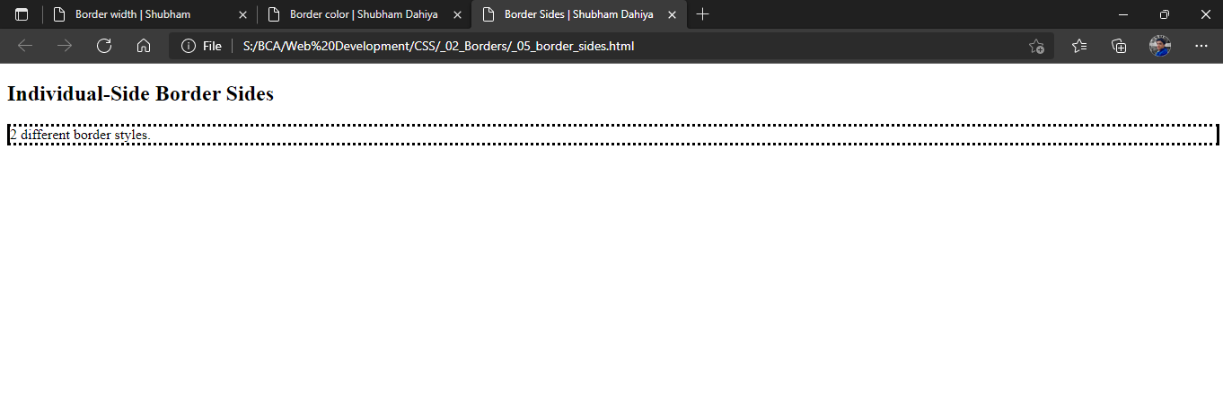

1. **Using division tag and id attributes**

<!DOCTYPE html>

<html>

<head>

<style>

#abc {

  background-color: black;

  color: white;

  padding: 20px;

  text-align: center;

}

#abcd {

  background-color: black;

  color: white;

  padding: 20px;

  text-align: center;

}

</style>

</head>

<body>

<h1>Styling with div class and id</h1>

<div id="abc">

    <h3> I am stylized in div tag with id</h3>

</div>

<h3 >This heading will not get style</h3>

</body>

</html>

**OUTPUT:**

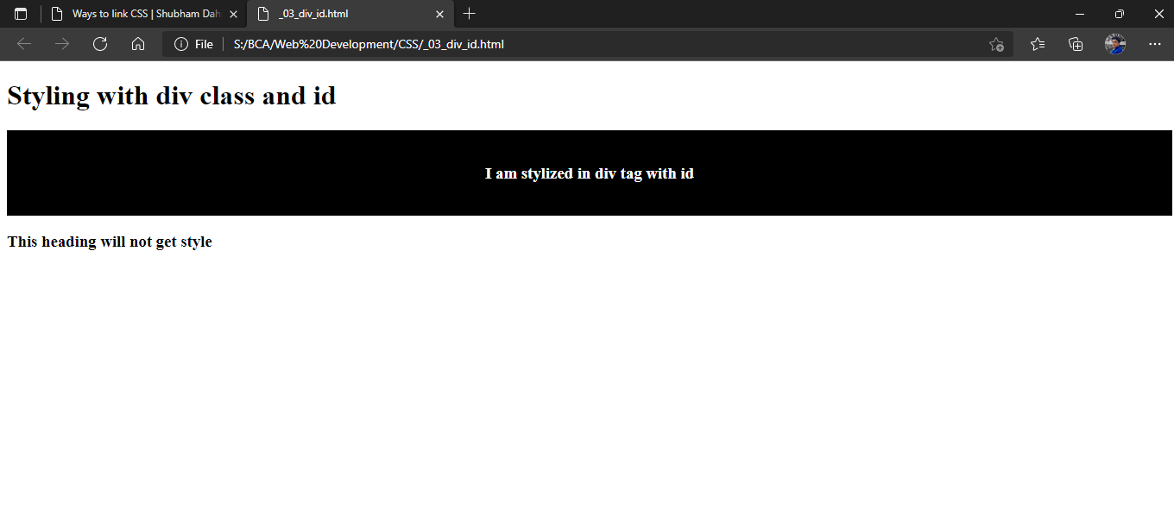

1. **Styling Links**

<!DOCTYPE html>

<html>

<head>

<style>

a.one:link {

    color: red;

}

a.one:visited {

    color: green;

}

a.one:hover {

color: hotpink;

text-decoration: underline;

}

a.two:link {

color:white; background-color:black;

}

a.two:visited {

color:cyan;

}

a.two:hover {

font-size:150%;

}

a.three:link {

color:#ff0000;

font-size:200%;

}

a.three:visited

{

color:#0000ff;

text-decoration:none;

}

a.three:hover {

background:#66ff66;

}

</style>

</head>

<body>

<h2>Styling Links</h2>

<p>Mouse over the links and watch them change layout:</p>

<p><b><a class="one" href="default.asp" target="_blank">This link changes color</a></b></p>

<p><b><a class="two" href="default.asp" target="_blank">This link changes font-size</a></b></p>

<p><b><a class="three" href="default.asp" target="_blank">This link changes background-color</a></b></p>

</body>

</html>

**OUTPUT:**

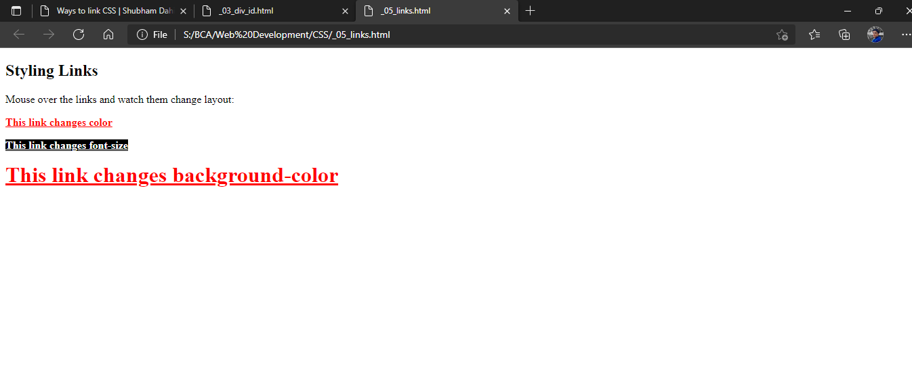

**New and emerging form elements:**

1. **Datalist**

<!DOCTYPE html>

<html>

<head>

<title>Datalist | Shubham Dahiya</title>

</head>

<body>

<h1>Datalist:</h1>

<form action="#" method="get">

<input list="animal" name="animal">

<datalist id="animal">

<option value="Dog">

<option value="Cat">

<option value="Cow">

<option value="Buffalo">

<option value="lizard">

</datalist>

<input type="submit">

</form>

</body>

</html>

**OUTPUT:**

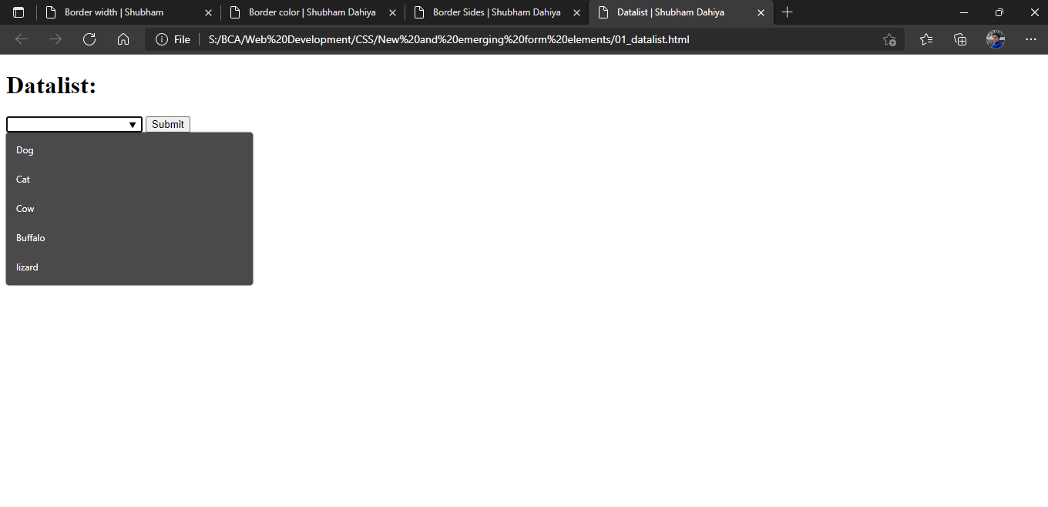

1. **Output**

<!DOCTYPE html>

<html>

<head>

<title>Output | Shubham Dahiya</title>

</head>

<body>

<form oninput="result.value = parseInt(first.value) + parseInt(second.value)">

<input name="first" type="number" value="0"> +

<input name="second" type="number" value="10"> =

<output name="result" for="first second">0</output>

</form>

</body>

</html>

**OUTPUT:**

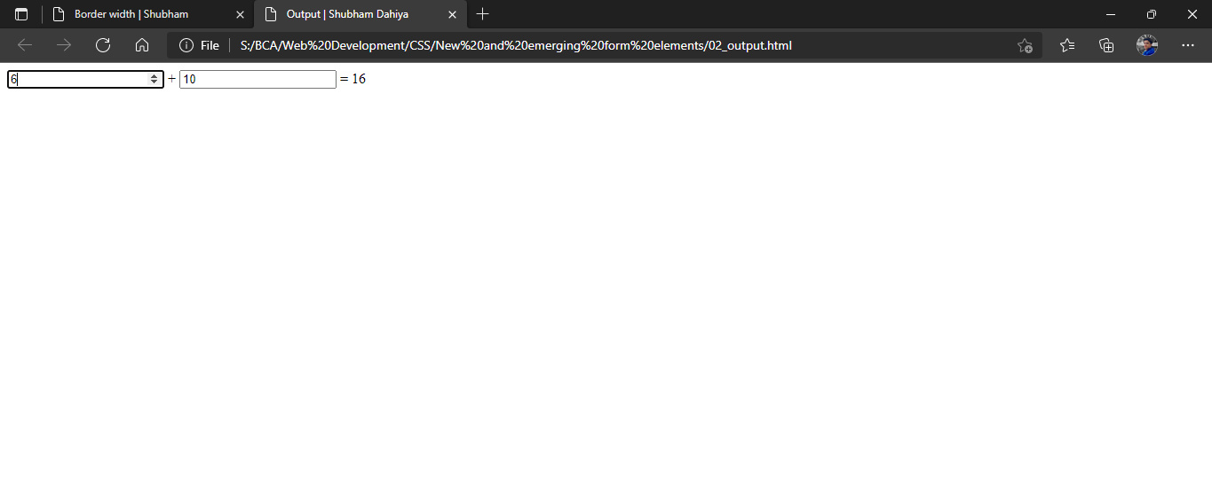

1. **Meter**

<!DOCTYPE html>

<html>

<head>

<title>Meter | Shubham Dahiya</title>

<style>

meter

{

width:100%;

height:35px;

}

</style>

</head>

<body>

<h1>Meter: </h1>

<p>Low: <meter value="20" min="0" max="100" low="25" high="75" optimum="100"></meter></p>

<p>Medium: <meter value="50" min="0" max="100" low="25" high="75" optimum="100"></meter></p>

<p>High: <meter value="80" min="0" max="100" low="25" high="75" optimum="100"></meter></p>

</body>

</html>

**OUTPUT:**

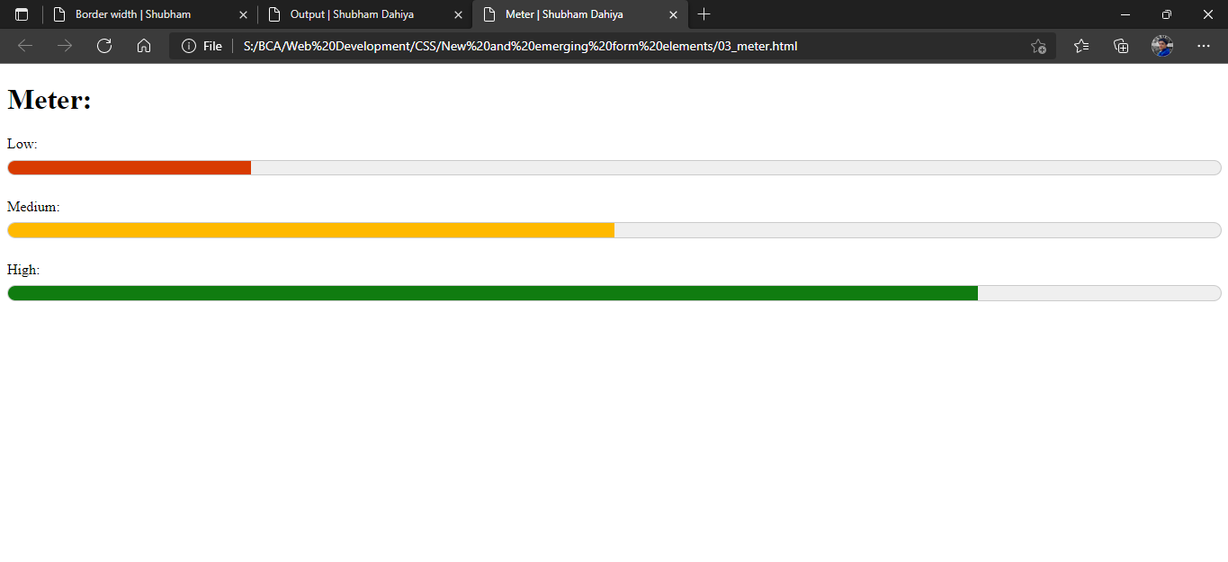

1. **Progress**

<!DOCTYPE html>

<html>

<head>

<title>Progress | Shubham Dahiya</title>

</head>

<body>

<h1>Progress: </h1>

<p>Indeterminate: <progress max="100"></progress></p>

<p>Progress 60%: <progress value="60" max="100"></progress></p>

</body>

</html>

**OUTPUT:**

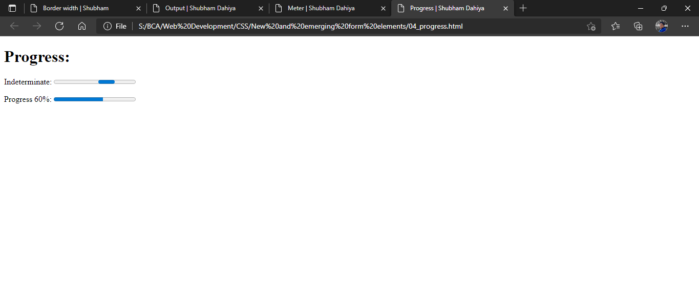

***JavaScript***

1. **Ways to link**

<!DOCTYPE html>

<html>

<head>

<title>Ways to link Javascipt | Shubham Dahiya</title>

<!-- linking javascript via external file -->

<script src="javascript.js"> </script>

<!-- Javascript inside body -->

<script>

console.log("Javascipt inside head")

</script>

</head>

<body>

<h1>Ways to link javascript/h1>

<p >Open console for output</p>

<script>

console.log("Javascipt inside body")

</script>

</body>

</html>

**OUTPUT:**

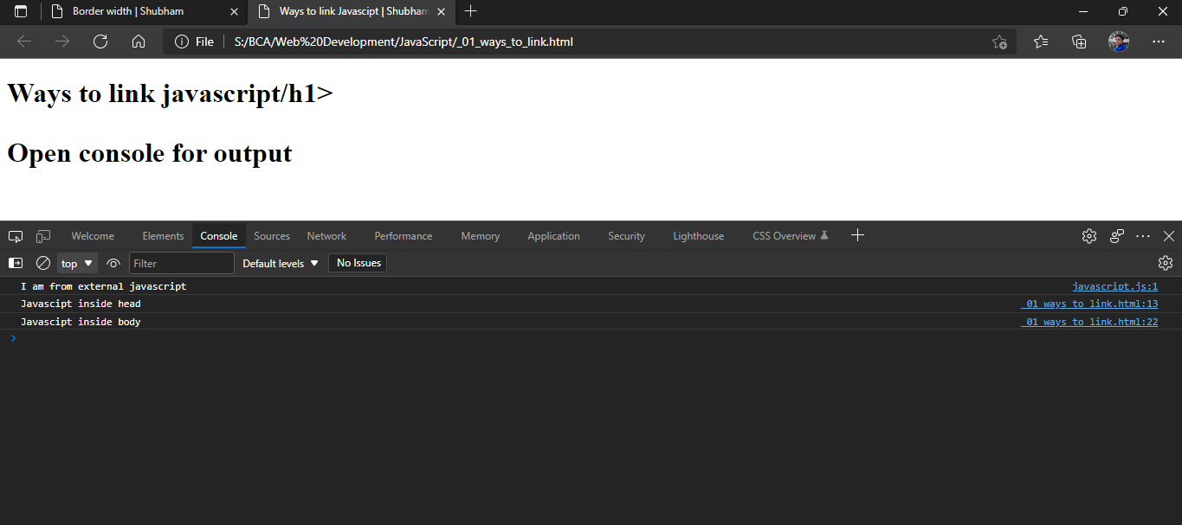

1. **Variable & Operator in JavaScript – Calculator Program**

<!DOCTYPE html>

<html>

<head>

<title>Calclator - Variable + Operator | Shubham Dahiya</title>

<script>

// take number 1

var number1 = parseFloat(prompt('Enter first number: '));

// take the operator input

var operator = prompt('Enter operator ( either +, -, * or / ): ');

//taking number 2

var number2 = parseFloat(prompt('Enter second number: '));

var result;

// using if...else if... else

if (operator == '+') {

result = number1 + number2;

}

else if (operator == '-') {

result = number1 - number2;

}

else if (operator == '*') {

result = number1 * number2;

}

else {

result = number1 / number2;

}

// result output

console.log(`${number1} ${operator} ${number2} = ${result}`);

</script>

</head>

<body>

<h1>Variable + Operator in Javascipt </h1>

<h3>Calculator Program</h3>

<p >Open console for output</p>

</body>

</html>

**OUTPUT:**

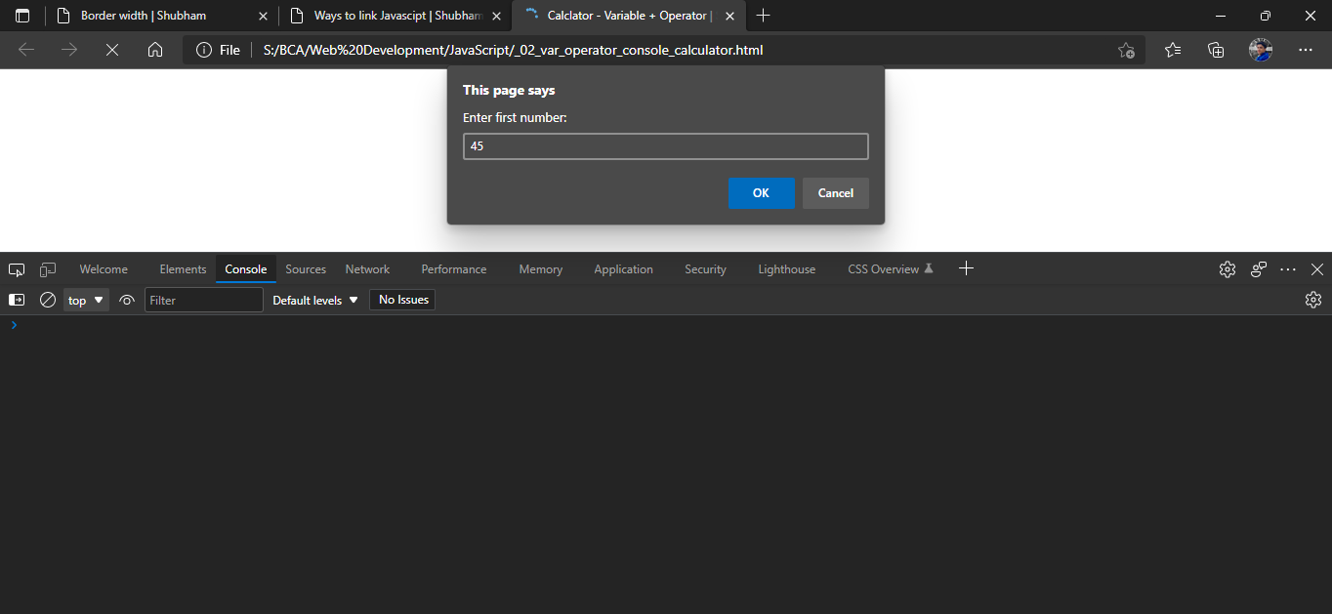

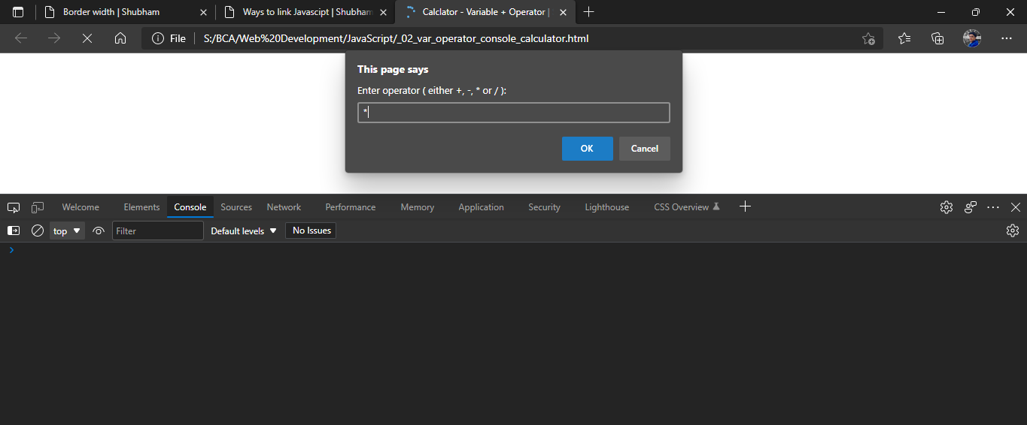

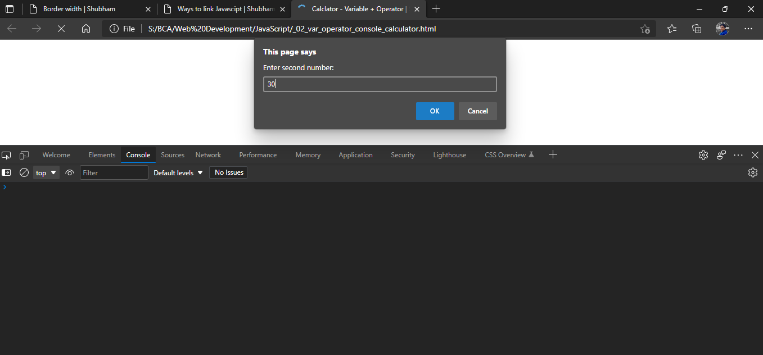

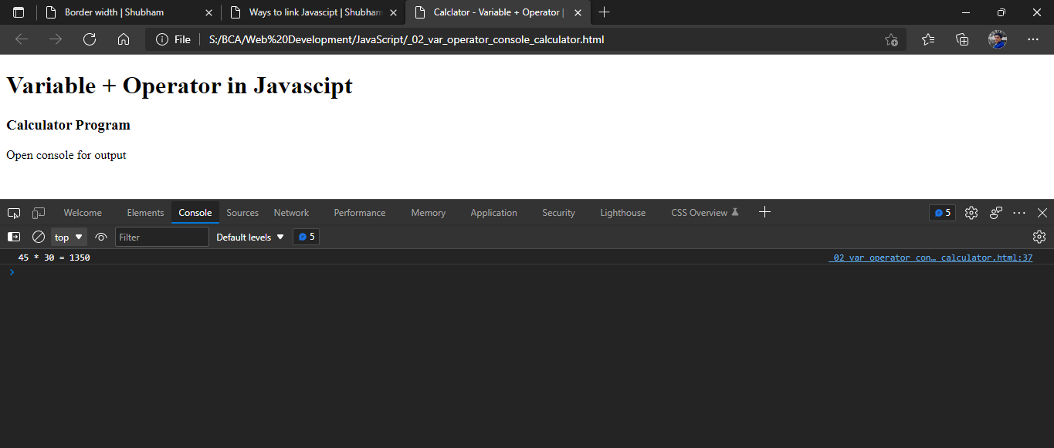

1. **Comparison operator**

<!DOCTYPE html>

<html>

<head>

    <title>Comparison Operator | Shubham Dahiya</title>

   <script>

        var a = 10, b = 20;

        var c = 'javascript';

        // equal to operator

        console.log("output for equal_to operator")

        console.log(a == 10);     // returns true

        console.log(b == '20');   // returns true

        console.log(c == 'Javascript');  //  returns false

        // not equal operator

        console.log("output for not_equal_to operator")

        console.log(a != 20); // returns true

        console.log(b != 'Javascript'); // returns true

        // strict equal operator

        console.log("output for strict_equal_to operator")

        console.log(a === 10); // true

        console.log(a === '10'); // false

        // strict not equal operator

        console.log("output for strict_not_equal_to operator")

        console.log(a !== 2); // false

        console.log(a !== '2'); // true

        console.log(b !== 'Hello'); // true

   </script>

</head>

<body>

   <h1>Variable + Operator in Javascipt </h1>

   <h3>Calculator Program</h3>

   <p >Open console for output</p>

</body>

</html>

**OUTPUT:**

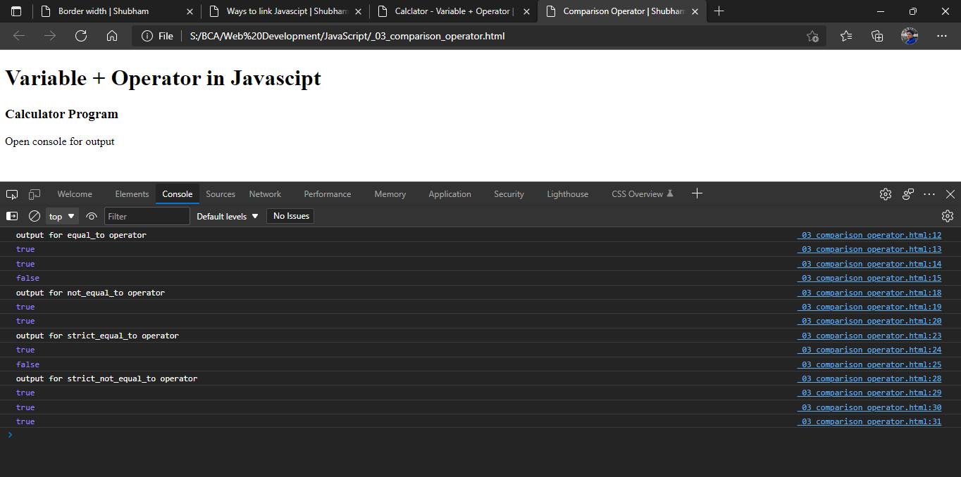

1. **Arithmethic operator**

<html>

<head>

    <title>Arithmetic Operator- Calculator | Shubham Dahiya</title>

<script>

// accept the number from the user through prompt box

const number1 = parseFloat(prompt ('Enter 1st number: '));

const operator = prompt('Enter operator to perform the calculation ( either +, -, * or / ): ');

const number2 = parseFloat(prompt ('Enter 2nd number: '));

let result;

//if-else ladder:

if (operator == '+') {

    result = number1 + number2;

}

else if (operator == '-') {

    result = number1 - number2;

}

else if (operator == '*') {

    result = number1 * number2;

}

else {

    result = number1 / number2;

}

// Result

window.alert(" Result is" + result);

</script>

<body>

    <h1>Calclulator - Arithmetic Operator</h1>

</body>

    </html>

**OUTPUT:**

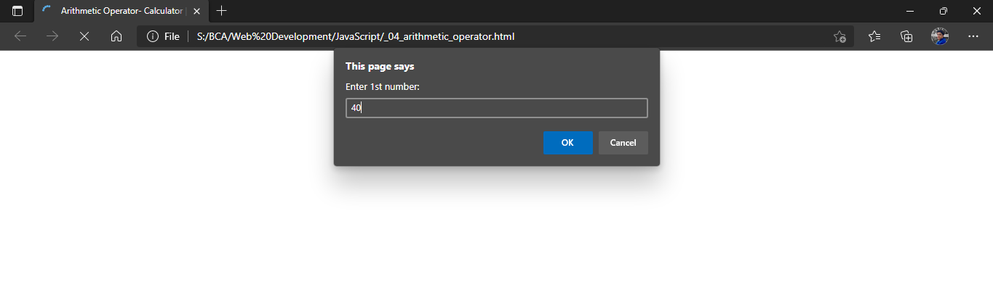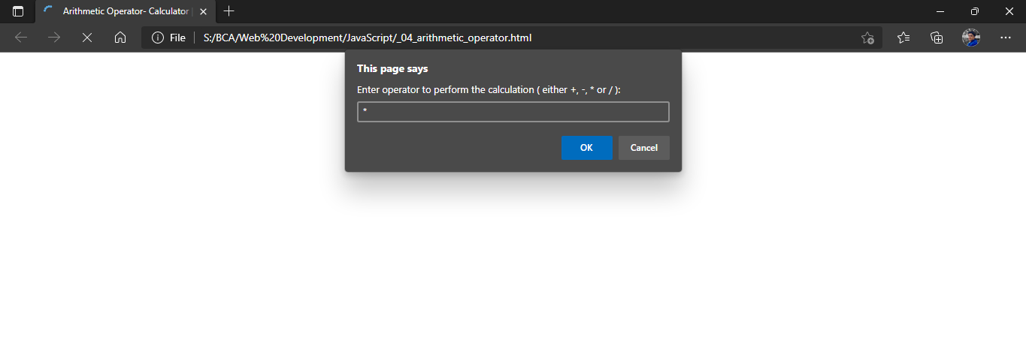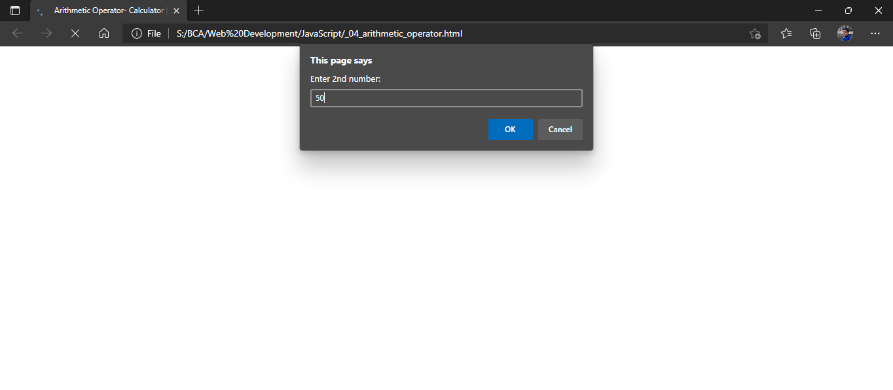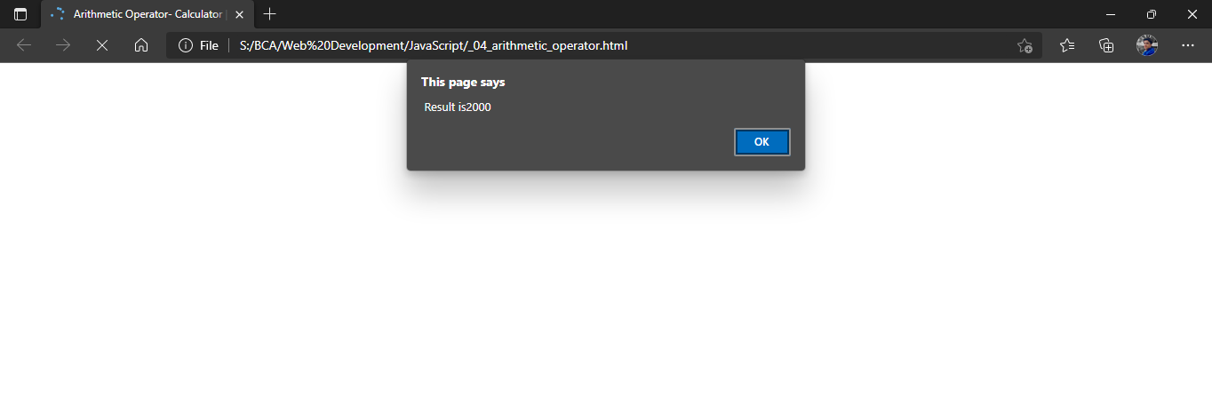

1. **Logical operator**

<html>

    <head>

        <title>Arithmetic Operator - Calculator | Shubham Dahiya</title>

    </head>

    <body>

    <h1>JS program for Comparison operator</h1>

    <p>a: true <br> b: false</p>

    <script type = "text/javascript">

            const a = true;

            const b = false;

            const linebreak = "<br />";

            document.write("(a && b) : ");

            document.write(a && b); //return false

            document.write(linebreak);

            document.write("(a || b) : ");

            document.write(a || b); //return true

            document.write(linebreak);

            document.write("!(a && b) : ");

            document.write(!(a && b)); //return true

            document.write(linebreak);

      </script>

   </body>

</html>

**OUTPUT:**

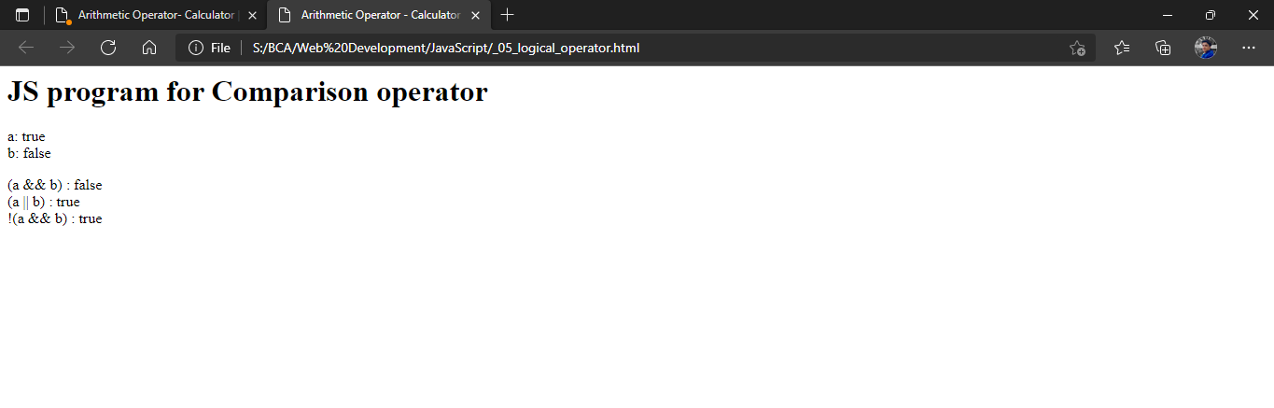

1. **Assignment operator**

<html>

    <body>

    <h1>Assigment operator in JS</h1>

      <script type = "text/javascript">

            var a = 80;

            var b = 55;

            document.write("initial value of a : " + a +"\n initial value of b : " + b );

            document.write("\nValue of a : (a = b) = ");

            document.write( a = b);

            document.write("<br />");

            document.write("Value of a : (a += b) = ");

            document.write(a += b);

            document.write("<br />");

            document.write("Value of a : (a -= b) = ");

            document.write(a -= b);

            document.write("<br />");

            document.write("Value of a : (a *= b) = ");

            document.write(a *= b);

            document.write("<br />");

            document.write("Value of a : (a /= b) = ");

            document.write(a /= b);

            document.write("<br />");

            document.write("Value of a : (a %= b) = ");

            document.write(a %= b);

            document.write("<br />");

      </script>

      <p>Set the variables to different values and different operators and then try...</p>

   </body>

</html>

**OUTPUT:**

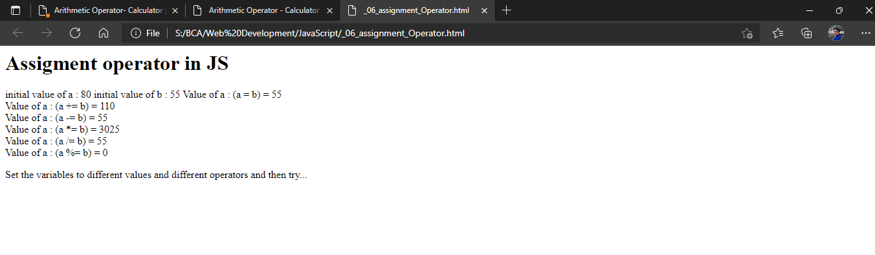

1. **Conditional operator**

<html>

<head>

<title>Ternary/Conditional Operator | Shubham Dahiya</title>

</head>

<body>

<h1>Ternary/Conditonal Operator</h1>

<script type = "text/javascript">

var a = 10;

var b = 20;

document.write ("((a > b) ? 100 : 200) => ");

result = (a > b) ? 100 : 200;

document.write(result);

document.write("<br />");

document.write ("((a < b) ? 100 : 200) => ");

result = (a < b) ? 100 : 200;

document.write(result);

document.write("<br />");

</script>

</body>

</html>

**OUTPUT:**

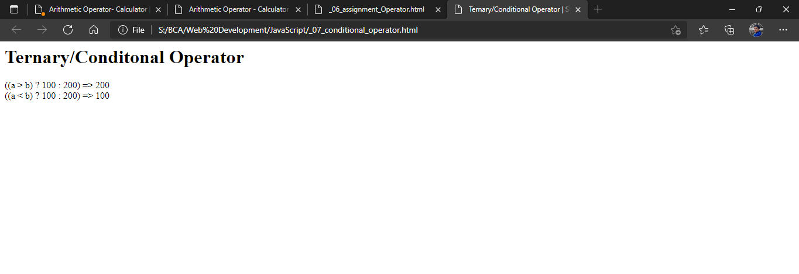

1. **Conditional typeOf Operator**

<html>

<body>

<h1>TypeOf operator with Conditional Operator</h1>

<script type = "text/javascript">

var a = 10;

var b = "Shubham";

var linebreak = "<br />";

var result = (typeof b == "string" ? "B is String" : "B is Numeric");

document.write("Result => ");

document.write(result);

document.write(linebreak);

result = (typeof a == "string" ? "A is String" : "A is Numeric");

document.write("Result => ");

document.write(result);

document.write(linebreak);

</script>

</body>

</html>

**OUTPUT:**

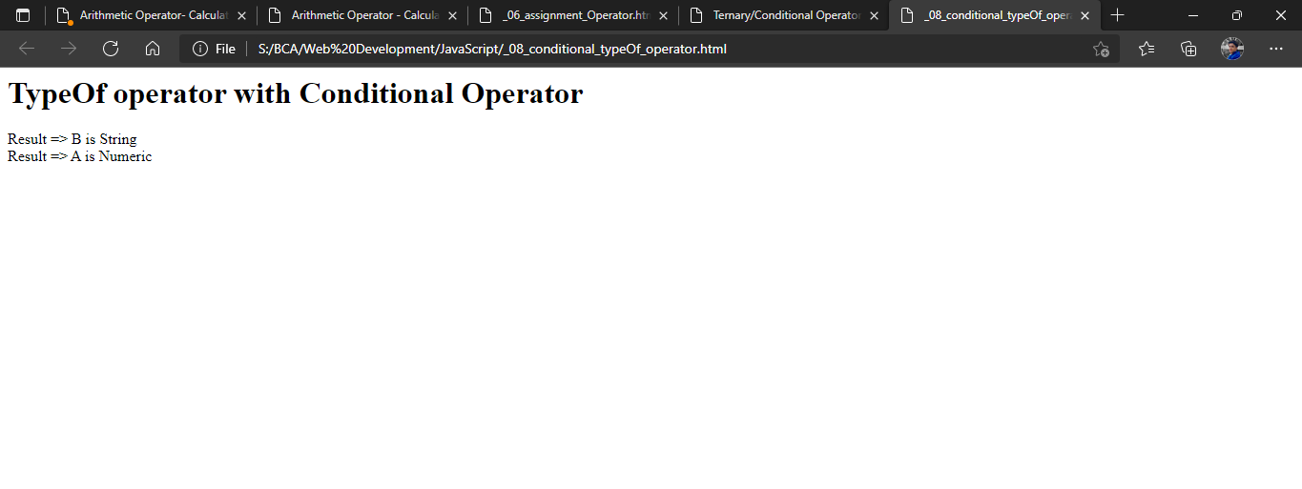

If else program

<!DOCTYPE HTML>

<html>

<head>

<title>if-else : Grade Calculator | Shubham Dahiya</title>

</head>

<body>

<h1>  if-else Statement in the JavaScript</h1>

<script type="text/javascript">

/*

if percentage >85 ->A

->A- if %<=85 and >80

->B if %<=80 and >70

->C if %<=70 and >60

->D if %<=60 and >40

->E if %<=40 and also should print 'candidate failed' if %<=35

Input

enter the percentage of student:

86

Output

Grade - 'A'

*/

var msg = 'enter the percentage of student:';

//msg for user input

var a = prompt(msg);

if(a>80)

{

document.write('Grade - A');

}

else if(a>70 && a<=80)

//message variable

{

document.write('Grade - B');

}

else if(a>60 && a<=70)

{

document.write('Grade - C');

}

else if(a<=60 && a>35)

{ document.write('Grade - D'); }

else if(a<=35)

{

document.write('Grade - E Candidate failed');

}

</script>

</body>

</html>

**OUTPUT:**

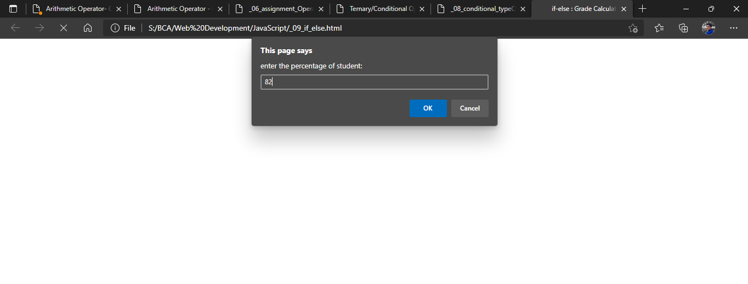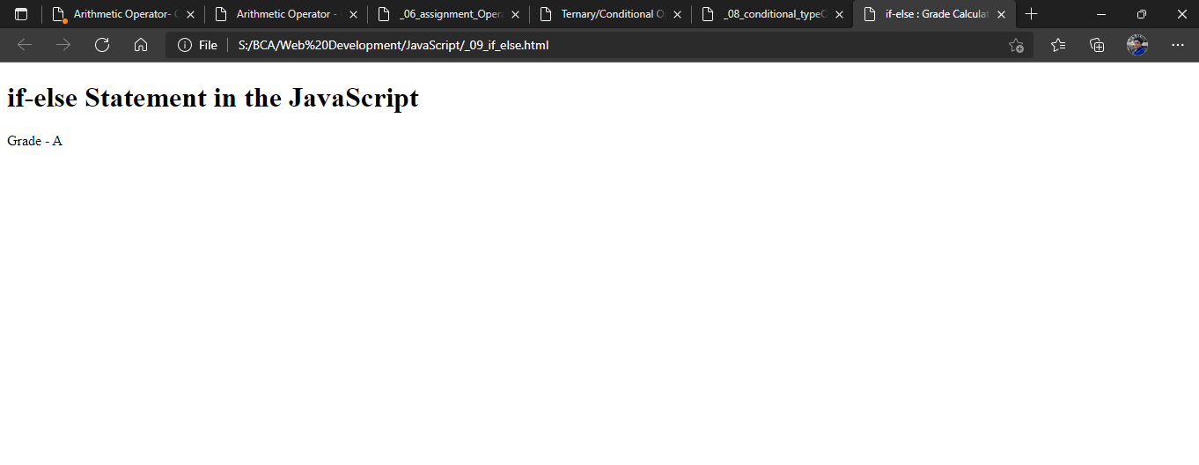

1. **Switch statement program**

<!DOCTYPE html>

<html lang="en">

<head>

<title>Switch: DayName | Shubham Dahiya </title>

</head>

<body>

<h1>Switch Statement : DayName program in JS</h1>

<script>

let day = prompt("Enter the number of Day: ");

day = parseInt(day)

let dayName;

switch (day) {

case 1:

dayName = 'Sunday';

break;

case 2:

dayName = 'Monday';

break;

case 3:

dayName = 'Tuesday';

break;

case 4:

dayName = 'Wednesday';

break;

case 5:

dayName = 'Thursday';

break;

case 6:

dayName = 'Friday';

break;

case 7:

dayName = 'Saturday';

break;

default:

dayName = 'Invalid day';

}

document.write("Entered day no.: " + day + "<br /> Calculated day: " + dayName)

</script>

</body>

</html>

**OUTPUT:**

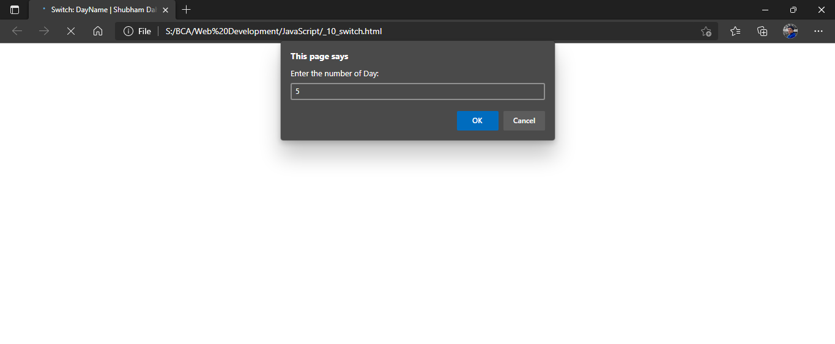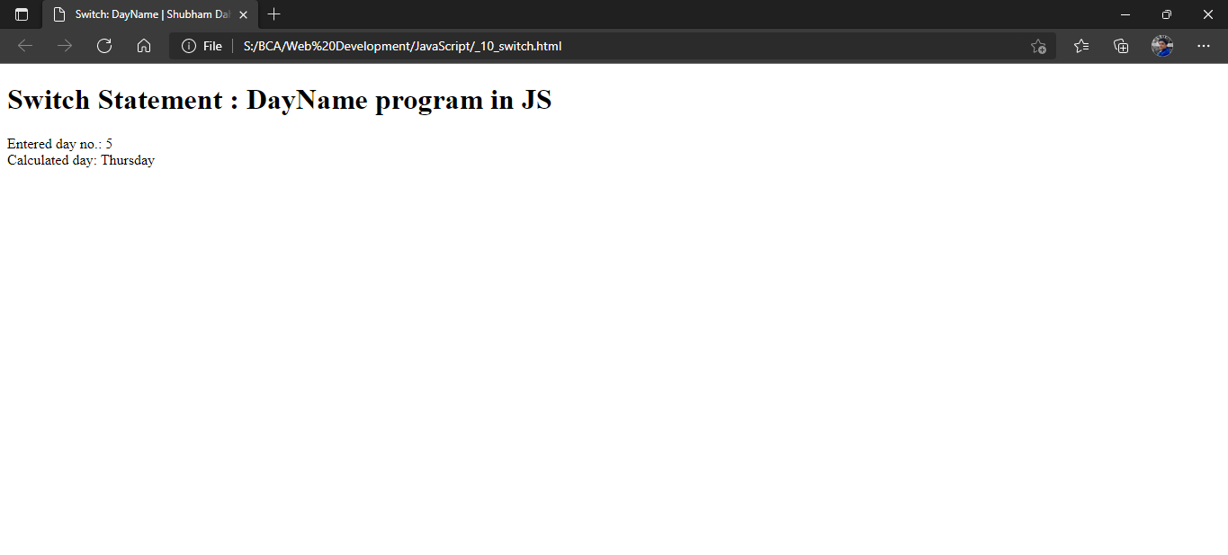

1. **For loop**

<!DOCTYPE html>

<html lang="en">

<head>

<title>For Loop - program to count sum of n natural numbers | Shubham Dahiya</title>

</head>

<body>

<h1>For Loop - program to count sum of n natural numbers</h1>

<script>

// program to display the sum of n natural numbers

let sum = 0;

let n = prompt("Enter no. of natural to find sum: ");

n = parseInt(n)

for(let i = n; i >= 1; i-- ) {

// adding i to sum in each iteration

sum += i; // sum = sum + i

}

document.write("Sum of " + n +" natural number is: " + sum)

console.log('sum:',sum);

</script>

</body>

</html>

**OUTPUT:**

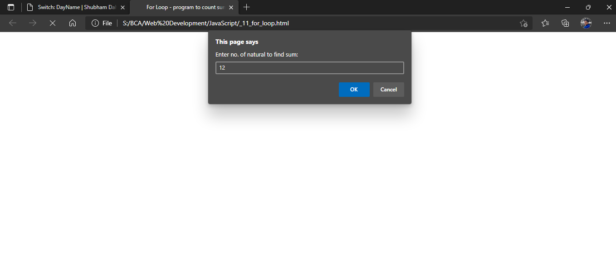

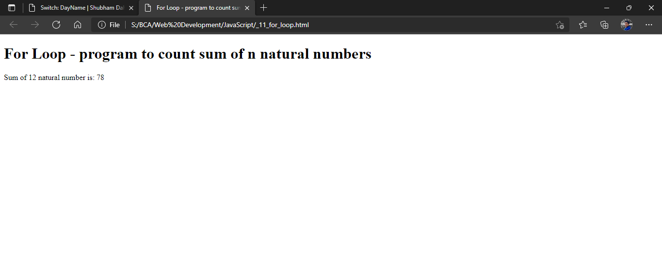

1. **While loop**

<!DOCTYPE html>

<html lang="en">

<head>

<title>while Loop - program print n natural numbers | Shubham Dahiya</title>

</head>

<body>

<h1>While Loop - program to print natural numbers </h1>

<script>

// program to display numbers from 1 to 5

// initialize the variable

let i = 1, n = 5;

// while loop from i = 1 to 5

while (i <= n) {

console.log(i);

document.write(i + "<br />")

i += 1;

}

</script>

</body>

</html>

**OUTPUT:**

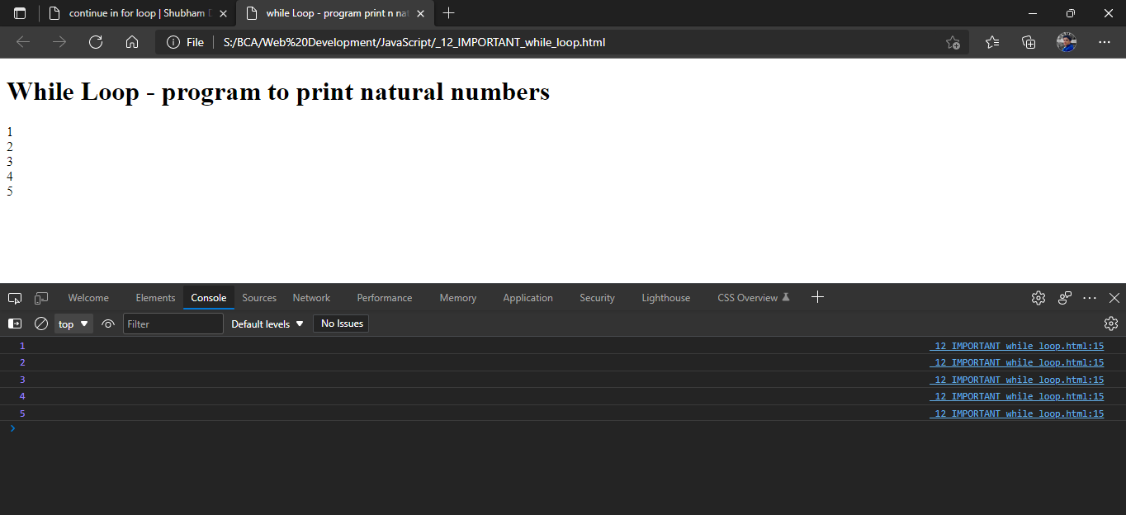

1. **Do while loop**

<html>

<head>

<title>do while - program to print number less than 20 | Shubham Dahiya</title>

</head>

<body>

<h1></h1>

<script type="text/javascript">

var i = 2;

document.write("Even numbers less than 20 are: <br />");

do

{

document.write(i + "<br />");

i = i + 2;

}while(i<20)

</script>

</body>

</html>

**OUTPUT:**

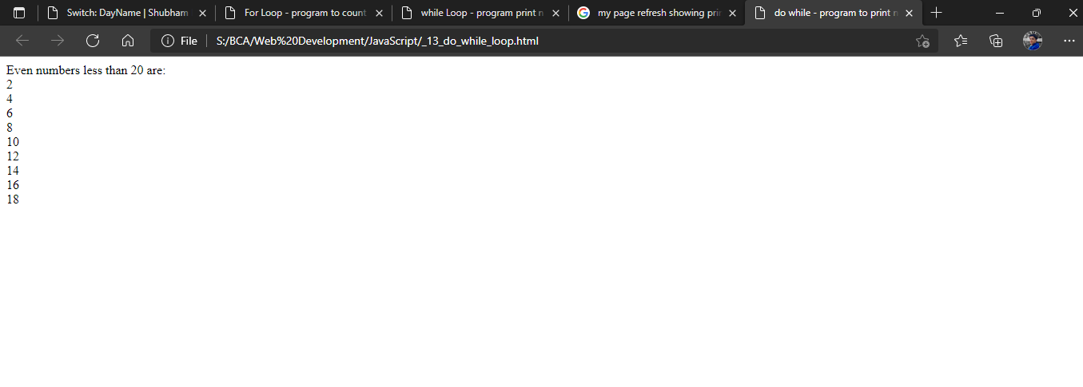

1. **Break Statement**

<!DOCTYPE html>

<html lang="en">

<head>

<title>break in while loop | Shubham Dahiya</title>

</head>

<body>

<h1>break statement in while loop</h1>

<script>

let sum = 0;

while(sum < 20) {

if(sum == 10) {

document.write("loop break at sum =  " + sum);

break;

}

document.write(`sum =${sum} <br/>`)

sum += 1;

}

</script>

</body>

</html>

**OUTPUT:**

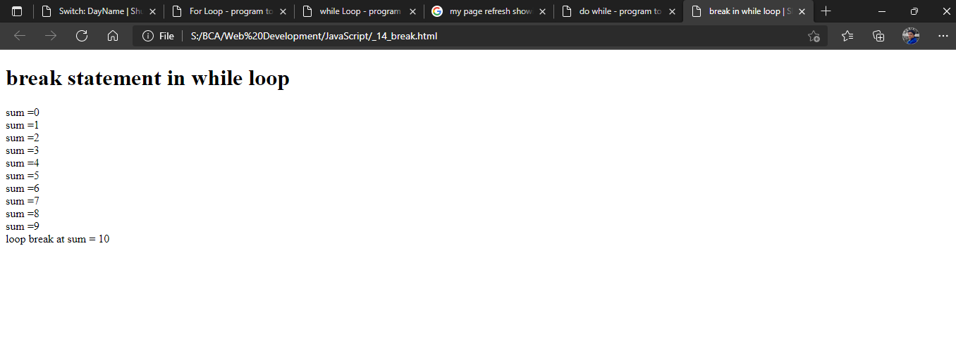

1. **Continue statement – Program to output odd numbers**

<!DOCTYPE html>

<html lang="en">

<head>

<title>continue in for loop | Shubham Dahiya</title>

</head>

<body>

<h1>Program to output odd numbers using Continue in for loop </h1>

<script>

for (let i = 0; i < 10; i++) {

if (i % 2 === 0) {

continue;

}

console.log(i);

document.write(i + "<br />")

}

</script>

</body>

</html>

**OUTPUT:**

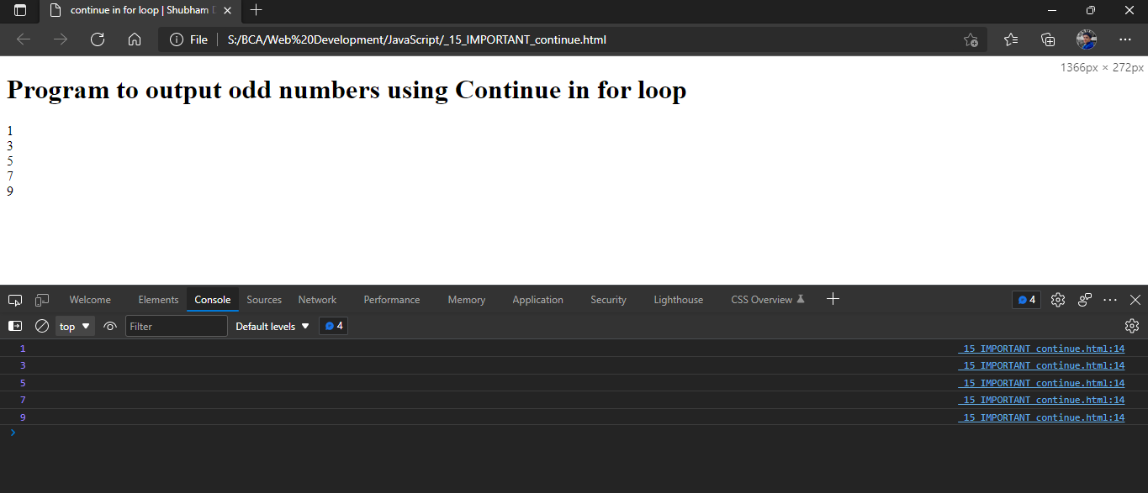

**Functions in JS**

1. **Function without return type, without parameter**

<!DOCTYPE html>

<html lang="en">

<head>

<title>Functions without returnType, parameter | Shubham Dahiya</title>

</head>

<body>

<h1>Functions without returnType, parameter - Program to find area of square</h1>

<script>

//variable declarations

var side = 20;

//function declaration

document.write("side of square: " + side + "<br/ >")

function area_of_square()

{

var area = side * side;

document.write("Area of the Square =" + " " + area);

}

//function call

area_of_square();

</script>

</body>

</html>

**OUTPUT:**

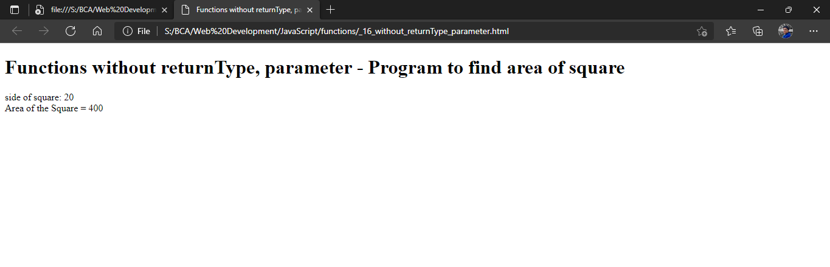

1. **Function with return type and parameter**

<!DOCTYPE html>

<html lang="en">

<head>

<title>Function with returnType + parameter | Shubham Dahiya</title>

</head>

<body>

<h1>Function with returnType + parameter</h1>

<script>

function factorial(num) {

if (num == 0)

return 1

let x = num - 1;

while (x > 1) {

num *= x;

x--;

}

return num;

}

let n = 8

document.write(`Factorial of ${n} is: ${factorial(n)}`)

</script>

</body>

</html>

**OUTPUT:**

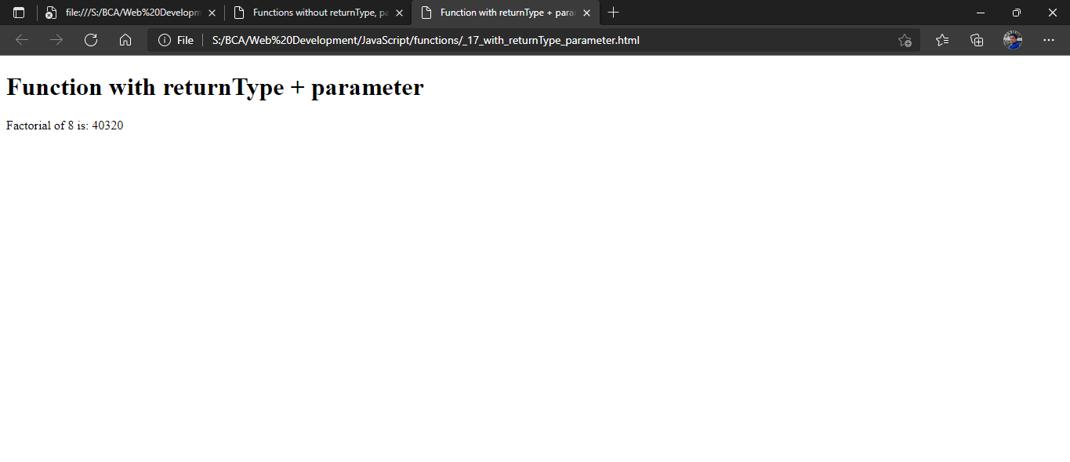

1. **Date Methods**

<!DOCTYPE html>

<html lang="en">

<head>

<title>Date - time class + methods | Shubham Dahiya</title>

</head>

<body>

<h2>Date and time Methods</h2>

<script>

var date= new Date();

document.write(date.getDate() +"<br>")

document.write(date.getFullYear()+"<br>")

document.write(date.getMonth()+"<br>")

document.write(date.getHours()+"<br>")

document.write(date.getMilliseconds()+"<br>")

document.write("apart of getting we can also set the values for the date class."+"<br>")

date.setDate("12")

document.write("after setting the date date is now"+date.getDate()+"<br>")

date.setMonth("9")

document.write( "after setting the month, the month is "+date.getMonth()+"<br>")

</script>

</body>

</html>

**OUTPUT:**

